setting up a kick start server
Tasks
1.Install the kickstart package on your Linux server and verify the installation by running the appropriate command.

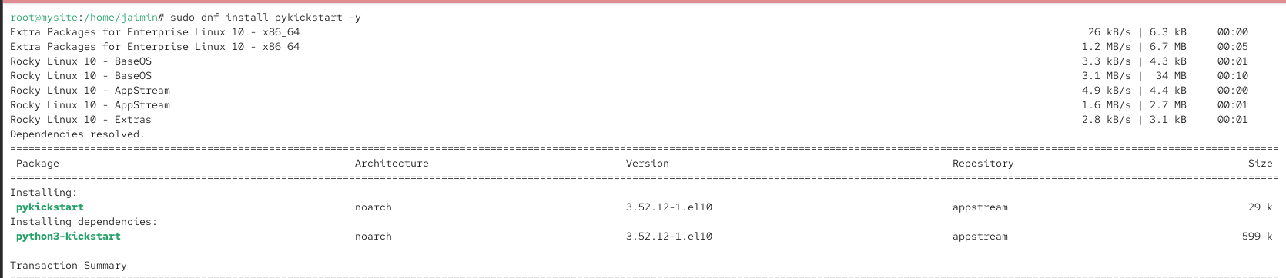
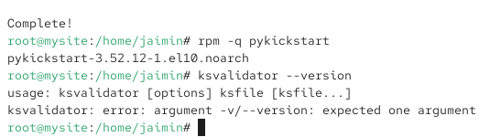
2.Create a basic kickstart configuration file (ks.cfg) that automates the installation of CentOS or Rocky Linux with your preferred timezone, root password, and a user account named 'student'.

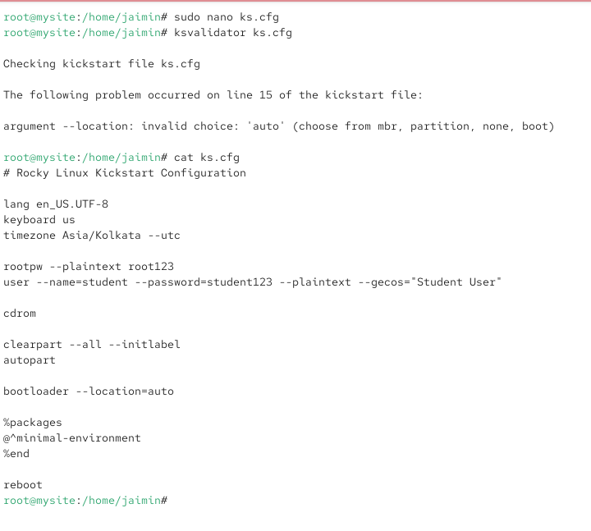
3.Set up an HTTP server (using Apache or nginx) to serve your kickstart file, and confirm you can access ks.cfg from another machine on the network via a browser or curl.

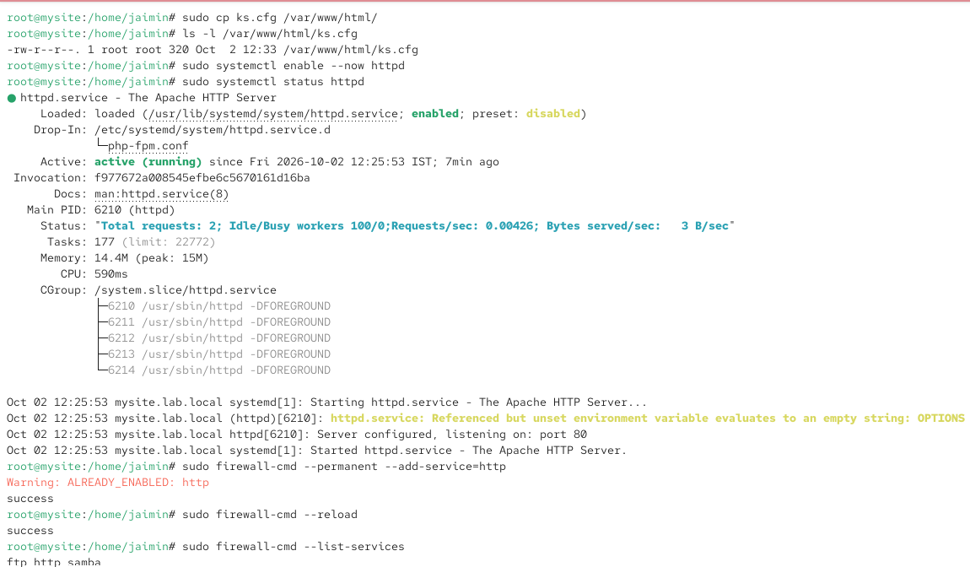
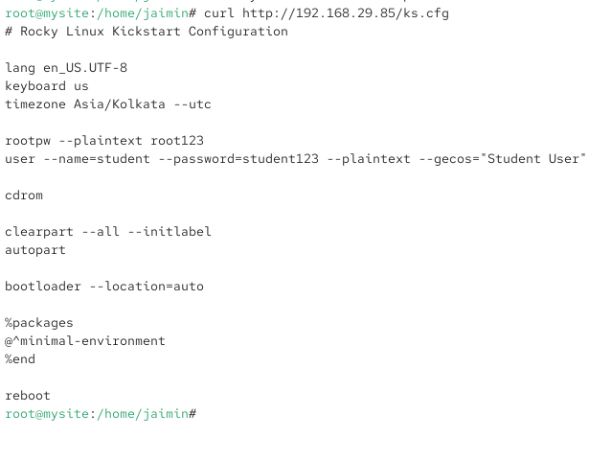

4.Modify your kickstart file to automatically install the GNOME desktop environment and add a post-install script that creates a text file /home/student/welcome.txt with the message 'Welcome to your automated Linux setup!'Hint: Use the %post section in your ks.cfg for post-install commands.

